

PROGRAMMING LAB

SHEIKH NASIR BIN KAMARUDIN  
NOR ANITAFAIROS BT ISMAIL

| WEEK 5 | Lab 3

## LAB 3 LOGIN

Download the file sources from **Classroom Google** to proceed for LAB 3**.**

**Question 1**

**Check for error or missing file, the inspect**

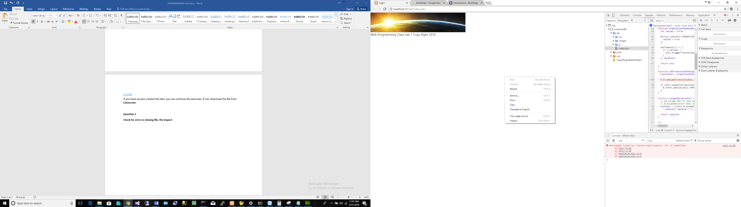

**Question 1**

Identify the missing file?

## Creating login form

Put in the code below in the index.php.

<?php

if (isset($_SESSION['UserId'])){

$to=$_SESSION['interface'];

gotoInterface($to);

}

?>

<?php

if (isset($_POST['txtUsername']))

{

$userid=$_POST['txtUsername']; //USER INPUT

$pass=$_POST['txtPassword'];

//SQL STATEMENT

$sql="select * from tbluser where UserId='".$userid."' and Password ='".$pass."'";

//SQL STATEMENT END

//$db=mysql_select_db($database,$virtual_con);

$result=mysqli_query($virtual_con,$sql);

//$result=mysql_query($sql);

if (!$result) {

echo 'Could not run query: ' . mysql_error();

exit;

}

$row = mysqli_fetch_assoc($result);

//echo $row;

$UserId=$row["UserID"];

$Name=$row["Name"];

//session_register("uName");

$_SESSION['UserID']=$UserId;

$_SESSION['Name']=$Name;

$_SESSION['UserType']=$row["UserType"];

$sql1="select interface from category where UserType='".$row["UserType"]."'";

$result1=mysqli_query($virtual_con,$sql1);

$row1 = mysqli_fetch_assoc($result1);

echo $row["UserID"];

//echo $row1;

if (empty($row["UserID"])){

echo 'No such user.Login Again';

}else

{

//call a function

$to=$row1["interface"];

$_SESSION['interface']=$to;

gotoInterface($to);

}

}

else{

?>

<form id="form1" name="form1" method="POST" action="login.php">

<p>Please enter your username and password</p>

<p>Username <input name="txtUsername" type="text" /></p>

<p>Password<input name="txtPassword" type="password" /></p>

<input name="btnLogin" type="submit" value="Login" />

</form>

<?php

}

?>

**Enhance your header in header.php using a proper CSS for Bootstrap as below**

<div class="header">

<div id="header-container" class="container">

<div class="headerdiv">

<a href="" class="headerleft">

<img src="images/header.jpg" width="100%" height="102" alt="header">

</a>

</div>

</div>

</div>

**Complete the codes until login is success.**

**Step**

1. **Check your database name**
2. **Check form name**
3. **Require links/function/file required to run the program**

**Question 2 Why the program was made in such way? What was the motive?**

**Question 3 What should be done to improve the program?**

**Question 4 Why did it go to login pages?**